# Brainstorm

**TIP**

You can select a sticky note and hit the pencil [switch to sketch] icon to start drawing!

### Before you collaborate

A little bit of preparation goes a long way with this session. Here’s what you need to do to get going.

**10 minutes**

**1**

### Define your problem statement

What problem are you trying to solve? Frame your problem as a How Might We statement. This will be the focus of your brainstorm.

**5 minutes**

**2**

### Brainstorm

Write down any ideas that come to mind that address your problem statement.

**10 minutes**

**3**

### Group ideas

Take turns sharing your ideas while clustering similar or related notes as you go. In the last 10 minutes, give each cluster a sentence-like label. If a cluster is bigger than six sticky notes, try and see if you and break it up into smaller sub-groups.

**20 minutes**

**4**

### Prioritize

Your team should all be on the same page about what's important moving forward. Place your ideas on this grid to determine which ideas are important and which are feasible.

**20 minutes**

### After you collaborate

You can export the mural as an image or pdf to share with members of your company who might find it helpful.

**Quick add-ons**

# & idea prioritization

**PROBLEM**

**How might we [your problem statement]?**

Use this template in your own brainstorming sessions so your team can unleash their imagination and start shaping concepts even if you're not sitting in the same room.

1. **Team gathering**

Define who should participate in the session and send an invite. Share relevant information or pre-work ahead.

1. **Set the goal**

Think about the problem you'll be focusing on solving in the brainstorming session.

1. **Learn how to use the facilitation tools**

Use the Facilitation Superpowers to run a happy and

**NANDISH.G**

DISADVANTAGES OF CLOUD COMPUTING

TECHNOLOGIES USED CLOUD COMPUTING

**TIP**

Add customizable tags to sticky notes to make it easier to find, browse, organize, and categorize important ideas as themes within your mural.

*Knowledge of mainstream programming languages and the ability to write code to build, deploy and manage applications

*Without any strugle find the job vacanciesin companies.

CLOUD COMPUTING USING SKILLS AND JOB TRACKING

*An IT professional responsible for any technological duties associated with cloud computing, including design, planning, management, maintenance and support.

**NIROSH KUMAR.J**

## 

*Data backup, disaster recovery, email

1. Virtualization ·
2. Service-Oriented Architecture ·
3. Grid Computing ·
4. Utility Computing

*Virtual desktops, software development and testing.

Big data analytics, and customer-facing web applications.

**PRASAN KUMAR.M**

## 

Back-up and restore data

*Once the data is stored in the cloud, it is easier to get back-up and restore that data using the cloud.

Excellent accessibility

*Cloud allows us to quickly and easily access store information anywhere, anytime in the whole world, using an internet connection. An internet cloud infrastructure increases organization productivity and efficiency by ensuring that our data is always accessible.

ADVANTAGES OF CLOUD COMPUTING

Low maintenance cost

*Cloud computing reduces both hardware and software maintenance costs for organizations.

Mobility

*Cloud computing allows us to easily access all cloud data via mobile.

IServices in the pay-per-use model

*Cloud computing offers Application Programming Interfaces (APIs) to the users for access services on the cloud and pays the charges as per the usage of service.

**SARAVANAN.R**

## 

*Data loss or theft.

*Data leakage.

Technology vulnerabilities, especially on shared environments

1. **Share the mural**

**Share a view link** to the mural with stakeholders to keep them in the loop about the outcomes of the session.

1. **Export the mural**

Export a copy of the mural as a PNG or PDF to attach to emails, include in slides, or save in your drive.

**10 minutes** to prepare

**1 hour** to collaborate

**2-8 people** recommended

productive session.

[**Open article**](https://support.mural.co/en/articles/2113740-facilitation-superpowers)

Account or service hijacking.

insecure interfaces and APIs.

*Types of cloud computing: private clouds, public clouds, hybrid clouds, and multiclouds

### Key rules of brainstorming

To run an smooth and productive session

### Keep moving forward

**Strategy blueprint**

Define the components of a new idea or strategy.

[**Open the template**](https://app.mural.co/template/e95f612a-f72a-4772-bc48-545aaa04e0c9/984865a6-0a96-4472-a48d-47639307b3ca)

**Customer experience journey map**

Stay in topic. Defer judgment.

Encourage wild ideas. Listen to others.

### Importance

If each of these

Understand customer needs, motivations, and obstacles for an experience.

[**Open the template**](https://app.mural.co/template/b7114010-3a67-4d63-a51d-6f2cedc9633f/c1b465ab-57af-4624-8faf-ebb312edc0eb)

Go for volume. If possible, be visual.

tasks could get

done without any difficulty or cost, which would have the most positive impact?

**Strengths, weaknesses, opportunities & threats**

Identify strengths, weaknesses, opportunities, and threats (SWOT) to develop a plan.

[**Open the template**](https://app.mural.co/template/6a062671-89ee-4b76-9409-2603d8b098be/ca270343-1d54-4952-9d8c-fbc303ffd0f2)

**TIP**

Participants can use their cursors to point at where sticky notes should go on the grid. The facilitator can confirm the spot by using the laser pointer holding the **H key** on the keyboard.

[**Share template feedback**](https://muralco.typeform.com/to/CiqaHVat?typeform-source=app.mural.co)

[**Share template feedback**](https://muralco.typeform.com/to/CiqaHVat?typeform-source=app.mural.co)

### Feasibility

Regardless of their importance, which tasks are more feasible than others? (Cost, time, effort, complexity, etc.)

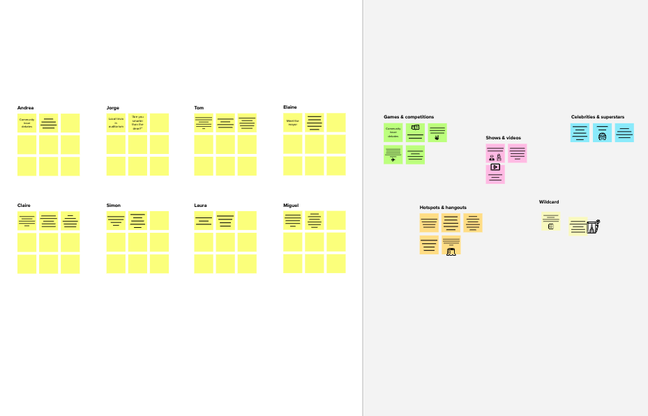

**Template**

**Need some inspiration?**

See a finished version of this template to kickstart your work.

[**Open example**](https://app.mural.co/template/e5a93b7b-49f2-48c9-afd7-a635d860eba6/93f1b98d-b2d2-4695-8e85-7e9c0d2fd9b9)